

ASSET VERIFICATION AND RECORDING TOOL KIT


Plot 31, Bukoto Street
P.O Box 7657, Kampala, Uganda
+256 (0) 39 2000216/0772525235
email: cpa@cpa.ug

www.cpa.com

August to September 2026

VERIFICATION DETAILS

NAME OF THE REGION: | WESTERN
SUB-REGION: | TOORO
Name of Local Government | KABAROLE
VERIFIER PARTICULARS
Full name | ZALWANGO MARIA, NASSEJJE NADIA, NABBOSA SUMAYA
Contact/ email and Telephone | 0751977570/ 0754884004/ 0708098456
Supervisor/ Sub team leader
Name | DEPAUL MBONIGABA
Contact | 0788483159
Date of submission

HEALTH CENTRES
INFORMANT INTERVIEW/DISCUSSION GUIDE (INCHARGE OR RESPONSIBLE PERSON)

Name of Health Centre: IRUHURA HC III

1a | Does the Facility have a record of all assets provided under UgIFT.  (Obtain a record and verify if it has the costs and numbers supplied | Yes, but it has no costs
1b | If Not ask how many were supplied and when. | Delivered on 08/08/2024

2 | How does this facility Maintain (repair/service/replace) the assets provided under Ugift

The facility uses the regional referral. They communicate to the district and the district sends technicians to repair the damaged equipments.

3 | Does the facility take regular record about functionality/ or breakdown of the assets provided? | Yes

4 | How has the UgIFT support helped in service delivery in the area, any issues, challenges and any recommendations for better program implementation.

It has provided space for the patients since new buildings are being set up.

Challenges
The glucometer is of a different type and they are done so getting another type is difficult in there are.

Recommendations

They recommend that they need more beds for male ward and female ward and also to provide the glucometer of a type that is easy to get.

PROCEED TO VERIFICATION AFTER THIS DISCUSSION

Health centre checklist

NAME OF LG: KABAROLE DISTRICT NAME OF HEALTH FACILITY: IRUHURA HEALTH CENTRE III

Equipment/ Item | Department | Asset Number | Item  Description | Life in Months | Tag Number ( engrave no.) | Date Of Purchase | Date Placed In Service | Recoverable cost | Cost | Acc Dep Cost | Net Book Value | Ytd Deprn | Equipment status | Remarks
B.P. Machine, Digital
B.P. Machine (Aneroid wall mounted) | Health |  | Boxed |  |  |  | 8/8/2024 |  |  |  |  |  | Good condition | 2 not in use still in store
Autoclave 20 Liters.,Duo Operated | Health |  | Silver in colour |  |  |  | 8/8/2024 |  |  |  |  |  | Good condition | 2 not in use
Bowl, Kick | Health |  | Silver |  |  |  | 8/8/2024 |  |  |  |  |  | Good condition | 1 not in use
Bowl Stand | Health |  | Silver |  |  |  | 8/8/2024 |  |  |  |  |  | Good condition | 3 not in use
Counting chamber Neubauer- Improved | Health |  | Boxed |  |  |  | 8/8/2024 |  |  |  |  |  | Good condition | 2 received and still in store
Cupboard Steel, Lockable | Health |  | Steel and Grey in colour |  |  |  | 8/8/2024 |  |  |  |  |  | Good condition | 4 Still in store
Drip Stand | Health |  | Have wheels and a metallic stand silver in colour |  |  |  | 8/8/2024 |  |  |  |  |  | Good condition | 9 are still in use.
ESR Stand | Health |  | Boxed |  |  |  | 8/8/2024 |  |  |  |  |  | Good condition | Still in store
Examination Couch | Health |  | Black mattresses with metallic stand |  |  |  | 8/8/2024 |  |  |  |  |  | Good condition | 4 are in use
Examination light,LED
Glucometer | Health |  | White in colour |  |  |  | 8/8/2024 |  |  |  |  |  | Good condition | 1 in use but the strips are done
Haemoglobin Meter, Digital | Health |  | Boxed |  |  |  | 8/8/2024 |  |  |  |  |  | Good condition | 2 are still in store
Height Meter | Health |  | White in colour |  |  |  |  |  |  |  |  |  | Good condition | 2 are in use
Instrument Trolley | Health |  | Metallic and silver with wheels |  |  |  | 8/8/2024 |  |  |  |  |  | Good condition | 4 are in store and not received
Microscope Binocular
Otoscope | Health |  | Boxed |  |  |  | 8/8/2024 |  |  |  |  |  | Good condition | 1 not yet used
Patient Screen | Health |  | Blue in colour |  |  |  | 8/8/2024 |  |  |  |  |  | Good condition | 5 not in use.
Patient Trolley | Health |  | Silver and metallic |  |  |  | 8/8/2024 |  |  |  |  |  | Good condition | Not yet used
Refrigerator, Basic | Health |  | White in colour |  |  |  | 8/8/2024 |  |  |  |  |  | Good condition | 2 not in use
Stethoscope | Health |  | Boxed |  |  |  | 8/8/2024 |  |  |  |  |  | Good condition | 8 are still in store
Stop Watch | Health |  | Boxed |  |  |  | 8/8/2024 |  |  |  |  |  | Good condition | 1 still in store
Stretcher | Health |  | White in colour with wheels |  |  |  | 8/8/2024 |  |  |  |  |  | Good condition | 2 not in use
Stove, Gas | Health |  | Boxed |  |  |  | 8/8/2024 |  |  |  |  |  | Good condition | 2 not in use.
Weighing Scale with Height Meter, Adult | Health |  | It has a screen and height in meters |  |  |  | 8/8/2024 |  |  |  |  |  | Good condition | 2 are in use
Weighing Scale, Infant | Health |  | White in colour |  |  |  | 8/8/2024 |  |  |  |  |  | Good condition | 1 Still in store
Weighing Scale, Toddler
Wheel Chair | Health |  | Black with wheels |  |  |  | 8/8/2024 |  |  |  |  |  | Good condition | 4 Not in use
Audio Visual Equipment
Medical Waste Bin | Health |  | Boxed |  |  |  | 8/8/2024 |  |  |  |  |  | Good condition | 23 not in use
Wall Clock | Health |  | Boxed |  |  |  | 8/8/2024 |  |  |  |  |  | One got broken. Others are in good condition | 4 still in store.
Diagnostic Equipment Set for MCH | Health |  | Boxed |  |  |  | 8/8/2024 |  |  |  |  |  | Good condition | 3 still in store
Diagnostic Equipment Set for OPD | Health |  | Boxed |  |  |  | 8/8/2024 |  |  |  |  |  | Good condition | 2 still in store
Glassware Set, Laboratory, Basic | Health |  | Boxed |  |  |  | 8/8/2024 |  |  |  |  |  | Good condition | 2 still in store
Hollow Ware Set, Treatment | Health |  | Boxed |  |  |  | 8/8/2024 |  |  |  |  |  | Good condition | 2 still in health
Instrument Set, Dressing | Health |  | Boxed |  |  |  | 8/8/2024 |  |  |  |  |  | Good condition | 4 still in store
Instrument Set, Basic ENT | Health |  | Boxed |  |  |  | 8/8/2024 |  |  |  |  |  | Good condition | 1 in store
Instrument Set, Suture
Pulse Oximeter, Hand held | Health |  | White in colour |  |  |  | 8/8/2024 |  |  |  |  |  | Good condition | 1 in use and 1 in store
Bed, Adult Patient with Mattress
Bed, Pediatric Patient, With Mattress | Health |  | Black mattresses |  |  |  | 8/8/2024 |  |  |  |  |  | Good condition | 4 not in use
Bedside Locker | Health |  | Grey in colour |  |  |  |  |  |  |  |  |  | Good condition | Some are in use and others in store.
Cupboard, Instrument |  |  |  |  |  |  |  |  |  |  |  |  | Good condition | Not yet received
Delivery Bed, Hydraulic Manual | Health |  | Black in colour |  |  |  | 8/8/2024 |  |  |  |  |  | Good condition | 1 Not yet used.
Oxygen Therapy Apparatus, Mininum 45L cylinder | Health |  | Boxed |  |  |  | 8/8/2024 |  |  |  |  |  | Good condition | 1 still in store
Resuscitator Manual, Infant, with all Mask sizes | Health |  | Boxed |  |  |  | 8/8/2024 |  |  |  |  |  | Good condition | 1 still in store
Resuscitator Manual, Adult, with all mask sizes | Health |  | Boxed |  |  |  | 8/8/2024 |  |  |  |  |  | Good condition | 2 still in store
Suction Apparatus, (Electric) | Health |  | White in colour |  |  |  |  |  |  |  |  |  | Good condition | 1 Not in use
Nebulizer, Ultrasonic | Health |  | Boxed |  |  |  | 8/8/2024 |  |  |  |  |  | Good condition | They received the electric one  1 still in store.
Oxygen Concentrator, Duo Flow | Health |  | White in colour with oxygen tubes |  |  |  | 8/8/2024 |  |  |  |  |  | Good condition | 1 Not in use
Bench | Health |  | Brown in colour |  |  |  | 8/8/2024 |  |  |  |  |  | Good condition | 4 in use
Disinfection Buckets | Health |  | White in colour |  |  |  | 8/8/2024 |  |  |  |  |  | Good condition | 6 still in store
Baby Cot | Health |  | Glassy with black mattresses |  |  |  | 8/8/2024 |  |  |  |  |  | Good condition | 2 not yet used.
Diagnostic Equipment Set for Ward | Health |  | Boxed |  |  |  | 8/8/2024 |  |  |  |  |  | Good condition | 2 still in store
Hollow Ware Set, Ward | Health |  | Boxed |  |  |  | 8/8/2024 |  |  |  |  |  | Good condition | 2 still in store
Instrument Set, Delivery | Health |  | Boxed |  |  | 8/8/2024 |  |  |  |  |  |  | Good condition | 5 still in store
Instrument Set, Stitch Removing | Health |  | Boxed |  |  | 8/8/2024 |  |  |  |  |  |  | Good condition | 5 still in store
MVA Kit | Health |  | Boxed |  |  | 8/8/2024 |  |  |  |  |  |  | Good condition | 5 still in store
Stool, Laboratory
Penguin Sucker | Health |  | Boxed |  |  | 8/8/2024 |  |  |  |  |  |  | Good condition | 3 still in store
Fetoscope, Dopplar | Health |  | Boxed |  |  | 8/8/2024 |  |  |  |  |  |  | Good condition | 2 still in store
Bubble CPAP
Centrifuge (Electric) | Health |  | White in colour |  |  | 8/8/2024 |  |  |  |  |  |  | Good condition | 1 still in store
Kangaroo Mother Care Chair | Health |  | Green in colour |  |  | 8/8/2024 |  |  |  |  |  |  | Good condition | 1 still in store
Radiant Infant Warmer
Haemoglobin Meter, Sahli | Health |  | Boxed |  |  | 8/8/2024 |  |  |  |  |  |  | Good condition | 2 still in store
Delivery Bed
Examination light | Health |  | Black in colour with light glasses with wheels |  |  | 8/8/2024 |  |  |  |  |  |  | Good condition | 3 Still in store
Instrument set, ENT Basic for HCIII | Health |  | Boxed |  |  | 8/8/2024 |  |  |  |  |  |  | Good condition | 1 still in store
Bag Valve mask (Ambu Bag), Neonatal | Health |  | Boxed |  |  | 8/8/2024 |  |  |  |  |  |  | Good condition | Still in store
Incubator
Office Chair | Health |  | Black in colour with soft seats and wheels |  |  | 8/8/2024 |  |  |  |  |  |  | Good condition | 7 still in store
Desk | Healh |  | Brown and wooden |  |  | 8/8/2024 |  |  |  |  |  |  | Good condition | 5not in use
Filing Cabinet | Health |  | Grey in colour with blue, green, orange lockers |  |  | 8/8/2024 |  |  |  |  |  |  | Good condition | 5 not in use
Non Residential Buildings | Health |  | Painted orange and white |  |  | 8/8/2024 |  |  |  |  |  |  | Good condition | Not in use and not enough
Residential Buildings | Health |  | Painted orange and cream |  |  | 8/8/2024 |  |  |  |  |  |  | Good condition | Not in use and not enough

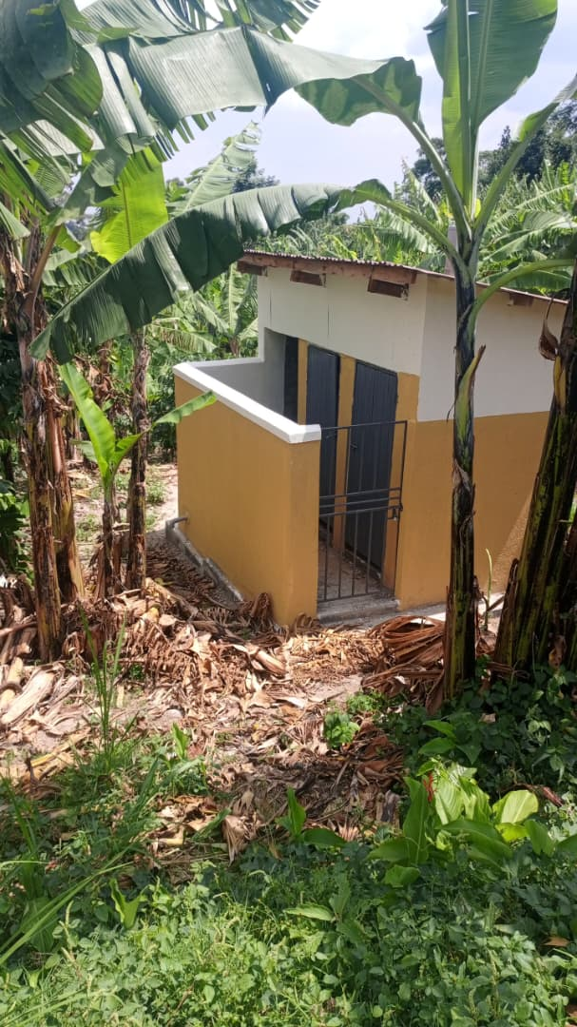
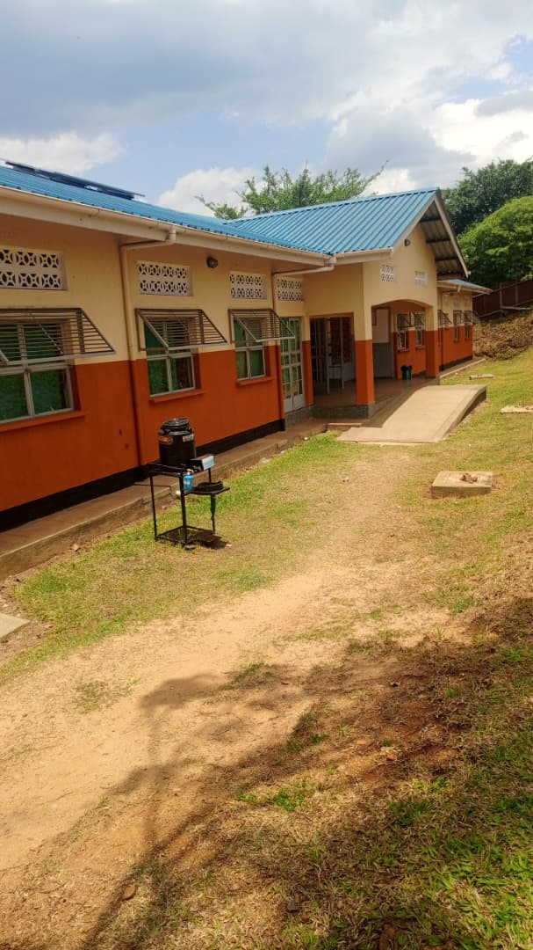
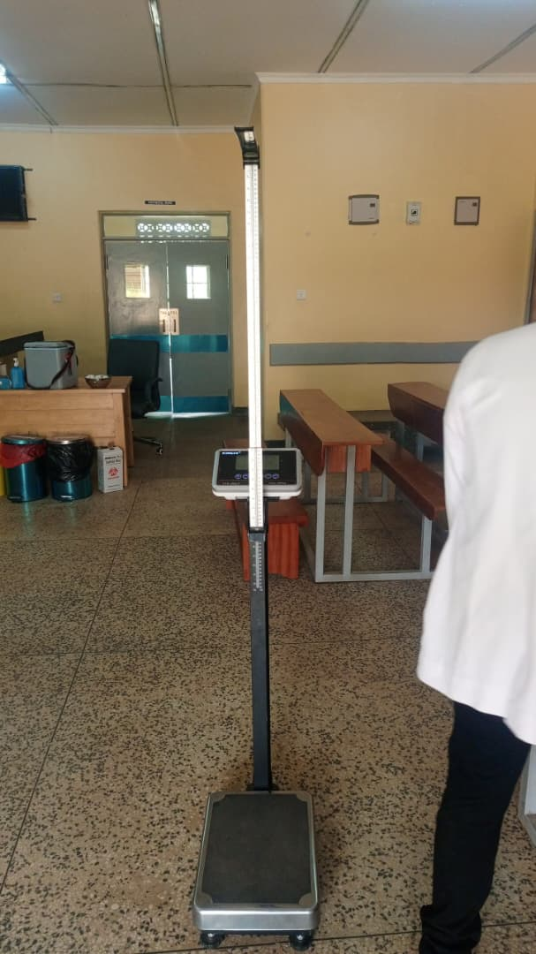
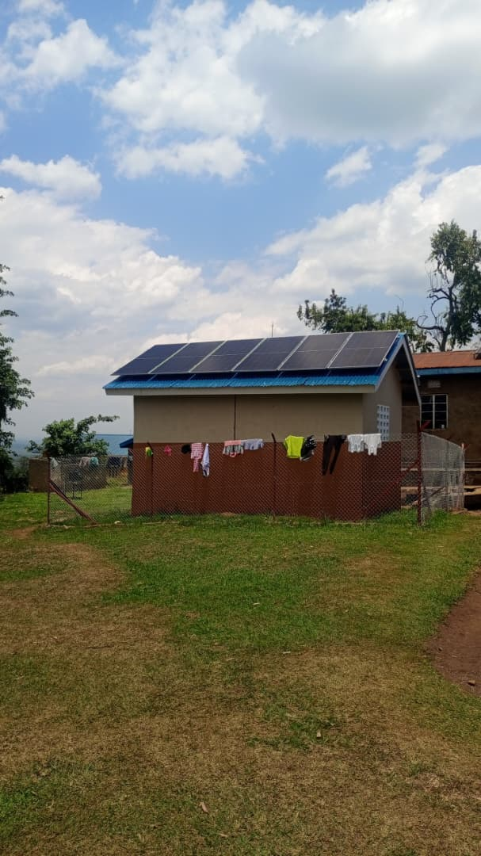

OPD Pit latrine Power House Weighing scale with a height meter
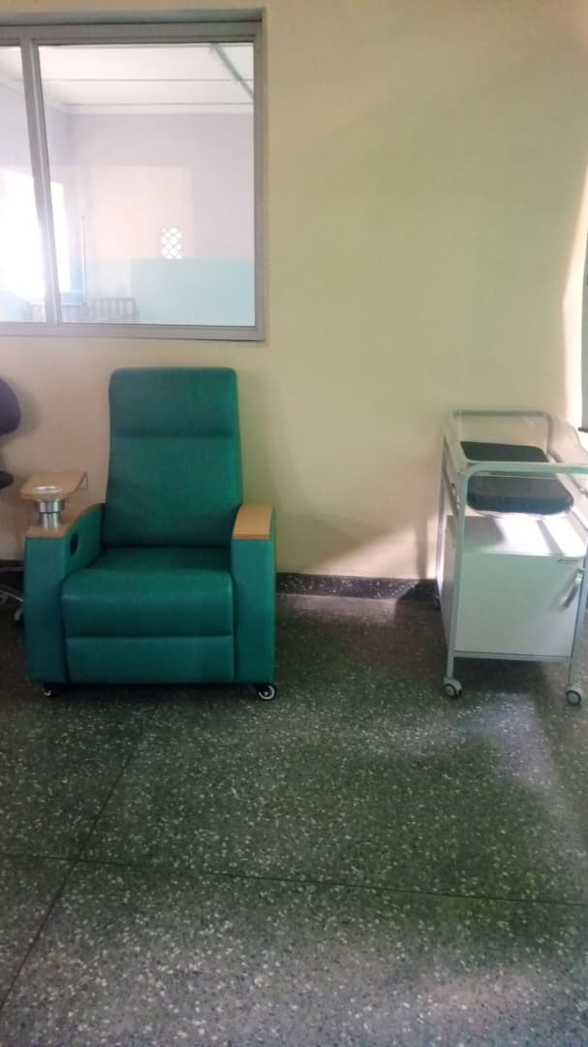
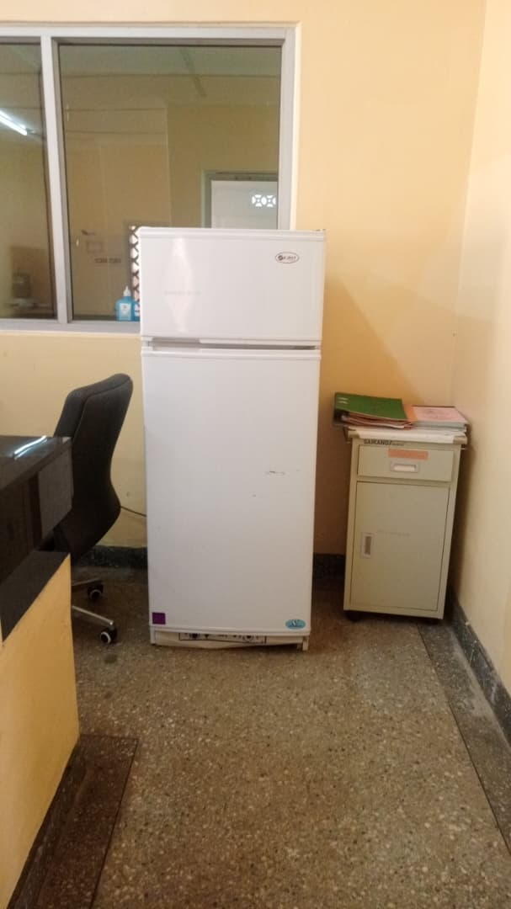
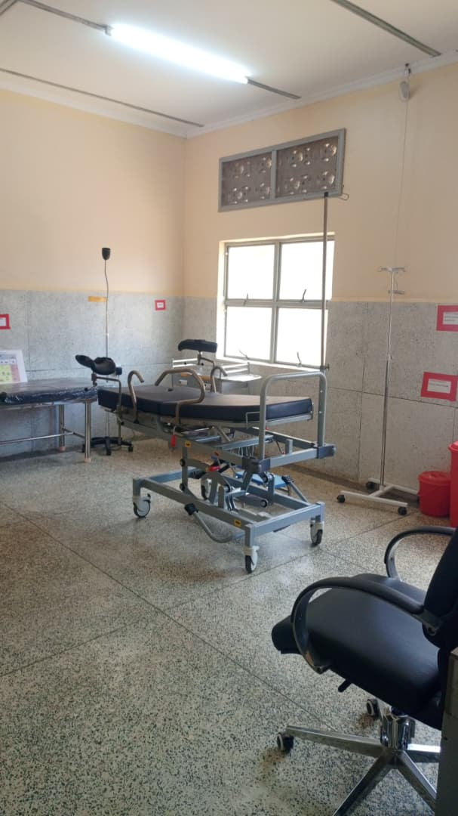

Delivery Fridge TV
bed

Kangaroo chair with a baby cot
Weighing scale with heighmeter & desk Tank Residentials
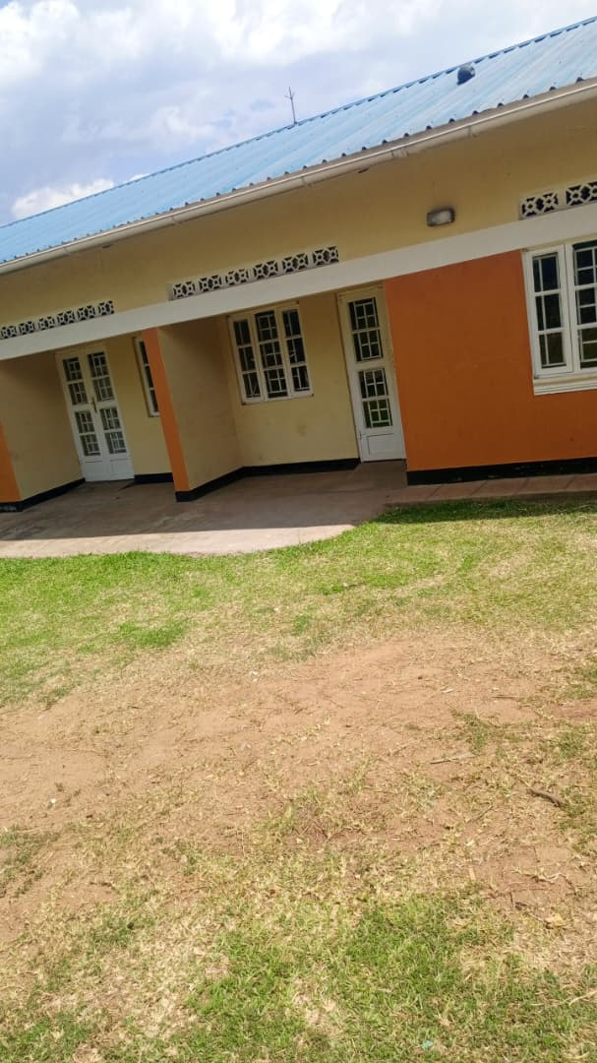
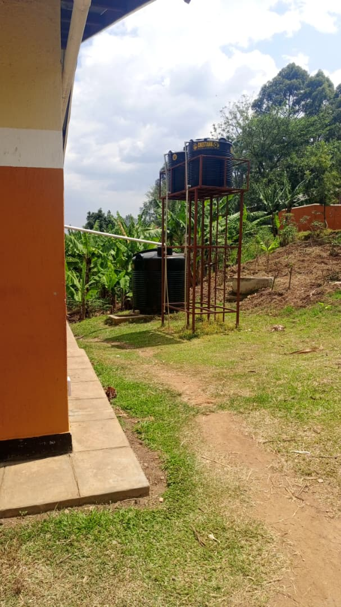
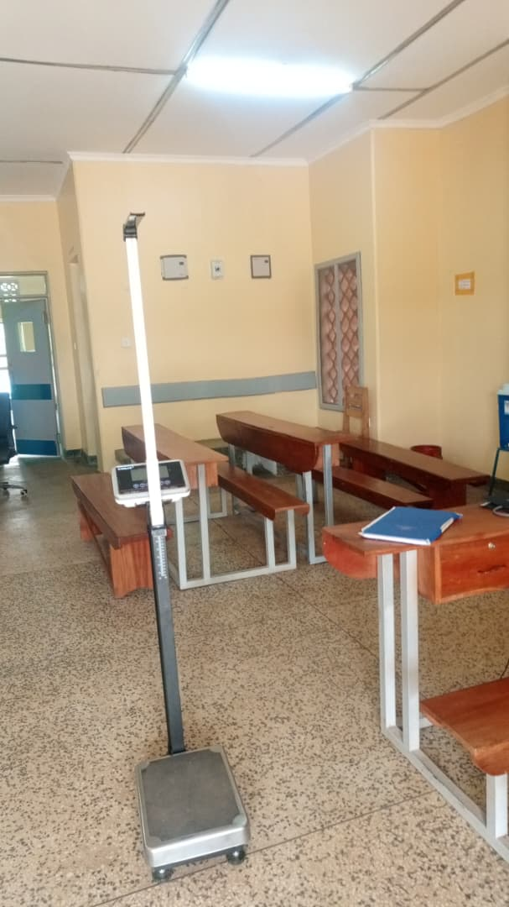

SCHOOL VERIFICATION CHECKLIST

SCHOOL INTERVIEW/DISCUSSION GUIDE

Name of school: NOMBE SEED SECONDARY SCHOOL

1a | Does the Facility have a record of all assets provided under UgIFT.  (Obtain a record and verify if it has the costs and numbers supplied | Yes, but it has no costs.
1b | If Not ask how many were supplied and when. | 426. he is not sure of the exact date.

2 | How does this facility Maintain (repair/service/replace) the assets provided under Ugift

The facility uses the school budget to repair/service/replace all the assets provided under UgIFT.

3 | Does the facility take regular record about functionality/ or breakdown of the assets provided?  Nonfunctional/ working, and reasons for non-functionality. | Yes. The desks were broken (some)

4 | How has the UgIFT support helped in service delivery in the area, any issues, challenges and any recommendations for better program implementation.

- Source of employment opportunities to the community.
- Provides education as a service to the community which has been led to its development.
Recommendations: If possible Ugift should provide more laboratory equipments and the ICT equiments for the students.
Also they are requesting for a boarding section to be constructed because a lot of children come from very far so they reach at school very late.

PROCEED TO VERIFICATION AFTER THIS DISCUSSION

SCHOOL FURNITURE
(School Desks, Office chairs, Laboratory stools, Book shelves)

Name of LG: NTOROKO DISTRICT Name of SCHOOL: NOMBE SEED SECONDARY SCHOOL

Equipment/ Item | Department | Asset Number | Item  Description | Life in Months | Tag Number ( engrave no.) | Date Of Pur | Date Placed In Service | Recoverable cost | Cost | Acc Dep Cost | Net Book Value | Ytd Deprn | Equipment status | Remarks
School desks | Education |  | Wooden and brown in colour |  |  |  |  |  |  |  |  |  | Two desks  were  faulty and  the rest were  in good  condition | They are in use.  100 desks received.
Office chairs | Education |  | Brown in colour. 9 were black with wheels. Some were maroon in colour with spongy seats and metallic seats. |  |  |  |  |  |  |  |  |  | Good condition | All are in use.  They are 161
Labaratory stools | Education |  | Brown in colour with metallic stands. |  |  |  |  |  |  |  |  |  | Good condition | They are all in use.  They are 120.
Bookshelves | Education |  |  |  |  |  |  |  |  |  |  |  |  | Were not constructed.
Tables | Education |  | Wooden and brown in colour |  |  |  |  |  |  |  |  |  | Good condition | They are all in use. They are 26 tables.

ICT ITEMS TO VERIFY
(Desktop Computer, Server Processor, Network Switch 24 Port, Multipurpose Printer, UPS, Projector, Air Conditioners, Server, CCTV Camera)

Name of LG…………………………………………………………………………… Name of SCHOOL………………………….………………………………………

Equipment/ Item | Department | Asset Number | Item  Description | Life in Months | Tag Number ( engrave no.) | Date Of Pur | Date Placed In Service | Recoverable cost | Cost | Acc Dep Cost | Net Book Value | Ytd Deprn | Equipment status | Remarks
ICT ITEMS |  |  |  |  |  |  |  |  |  |  |  |  |  | They never received any ICT items

BUILDINGS TO VERIFY
(Non- Residential and Residential, Kitchen, Toilets/Pit latrine Water tanks, Fences etc.)

Name of LG…………………………………………………………………………… Name of SCHOOL………………………….………………………………………

Equipment/ Item | Department | Asset Number | Item  Description | Life in Months | Tag Number ( engrave no.) | Date Of Pur | Date Placed In Service | Recoverable cost | Cost | Acc Dep Cost | Net Book Value | Ytd Deprn | Equipment status | Remarks
Non residential | Education |  | Painted cream and white |  |  |  |  |  |  |  |  |  | Good condition | They are in use. They are seven in number.
Residential | Education |  | Painted cream and white |  |  |  |  |  |  |  |  |  | Good condition | They are all in use.  They are 3 in number.
Kitchen | Education |  |  |  |  |  |  |  |  |  |  |  |  | Not built.
Toilets | Education |  |  |  |  |  |  |  |  |  |  |  |  | Not constructed
Pit latrine | Education |  | They are painted cream and white. |  |  |  |  |  |  |  |  |  | Good condition | They are all in use.  They are all in use.  3 are for residential and 3 are not for residential.
Water tanks | Education |  | They are black in colour |  |  |  |  |  |  |  |  |  | One is faulty and two are working. | Two in use. They re three. Not constructed.
Fence |  |  |  |  |  |  |  |  |  |  |  |  |  | Not constructed.

